# Mineral Properties

If any of the following statements is a characteristic of a mineral, place a check mark beside it. **If it is not, leave it blank**.

1. N Made of one or more elements on the periodic table
2. Y Is formed by years of compression under the earth’s crust
3. Y Is formed by cooling after a volcanic eruption
4. Y Is a solid
5. Y Has a unique crystalline shape
6. N Can be melted easily with a simple campfire
7. Y Has luster, a hardness number and specific density
8. N Is usually found on the coastal areas of the United States

We use different tests to identify a mineral. **Match** each test with its name.

|  |  |
| --- | --- |
| 1. Moh’s Scale C | 1. Relative heaviness of a mineral |
| 1. Crystalline Structure D | 1. Colour it leaves when scratched on porcelain |
| 1. Specific Gravity A | 1. How easily it scratches other materials or it’s hardness |
| 1. Streak B | 1. Shape as it grows |
| 1. Lustre F | 1. Breaks along a plane/line |
| 1. Fracture G | 1. Appearance |
| 1. Cleavage E | 1. Breaks unevenly or shatters |

1. Take the following list of items and give their **hardness** on the Moh’s scale. You may have to use a text book or the internet to find your answers.

|  |  |  |  |
| --- | --- | --- | --- |
| Diamond 10 | A nail 2.5 | A penny 3.5 | Talc 1 |
| Glass 5.5 | Steel 6.5 | Amethyst 7 | Topaz 8 |

1. **Explain** the rate of change in temperature that determines crystal **size**?

|  |
| --- |
| If the magma cools quickly, the crystals do not have much time to form, so |
| They are very small. If the magma cools slowly, then the crystals have enough |
| time to grow and become large |

1. **Describe** 3 common minerals. Include a **property** of each.

|  |
| --- |
| Diamond – very hard and made completely of carbon |
| Quartz – glassy lustre, can be many colours |
| Talc – soft and dull |

1. **Describe** what is meant by the cleavage of a mineral’s crystal?

|  |
| --- |
| Cleavage refers to the splitting of a crystal along a smooth plane. |
| A cleavage plane is a plane of structural weakness along which a mineral is likely |
| to split. |

1. What is the **difference** between a rock and a mineral?

|  |
| --- |
| A rock is made up of minerals and can be comprised of more than one. A mineral |
| Is made of a single element or compound |
|  |

# ROCKS

1. What is a type of rock that is formed from magma?

|  |
| --- |
| Igneous |

1. What does intrusive and extrusive mean? Where can these types of rocks be found and what type of rocks are, they?

|  |
| --- |
| Intrusive means interior. Intrusive rocks are igneous rocks that form from cooled magma within the Earth. An example is granite.  Extrusive means exterior. Extrusive rocks are igneous rocks that form from cooled lava on the surface of the Earth. An example is pumice. |

1. What type of rock is formed through weathering, erosion, compaction and cementation?

|  |
| --- |
| Sedimentary |

1. What happens when the above rock types are exposed to intense heat and pressure? What type of rock is formed?

|  |
| --- |
| The minerals in the rock either recrystallize when exposed to large amounts of heat or form lines of minerals when exposed to intense pressure – called foliation. Metamorphic rocks are formed from this. |

1. Describe the two types of metamorphism.

* Regional Metamorphic - this is where a large area of rock is affected by plate tectonic activity resulting in extreme pressure.
* Contact Metamorphism - is where rocks are changed, usually via heat, on a local scale, such as “baking” sedimentary rocks next to magma or lava from an intrusion

1. Identify the rocks in the following table as either Igneous, Sedimentary or Metamorphic. Place a I, S or M next to each.

|  |  |  |  |
| --- | --- | --- | --- |
| GNEISS | M | QUARTZITE | M |
| SANDSTONE | S | CONGLOMERATE | S |
| GABBRO | I | PUMICE | I |
| GRANITE | I | BRECCIA | S |
| OBSIDIAN | I | BASALT | I |
| SLATE | M | LIMESTONE | S |
| MARBLE | M | SCHIST | M |

1. Explain how marble is formed, which rock it is form from and the process involved?

|  |
| --- |
| Marble is a metamorphic rock formed when limestone is exposed to high |
| temperatures and pressures. Marble forms under such conditions because the |
| Calcite forming the limestone recrystallizes forming a denser rock consisting of |
| roughly equigranularity calcite crystals. |

1. Construct a table outlining the different types of sedimentary rocks and their features.

|  |  |
| --- | --- |
| Type of sedimentary Rock | Features |
| Clastic | cemented-together clasts, solid fragments and grains broken off of preexisting rocks |
| Organic | shells, bones and hard parts of animals, as well as carbon-rich relics of plants or other organisms |
| Chemical (Crystalline) | minerals that precipitated directly from water solutions |

# Weathering and erosion

1. What is weathering?

|  |
| --- |
| Weathering is the breakdown of rocks at the Earth's surface, by the action of |
| rainwater, extremes of temperature, and biological activity. |
|  |

1. What are the different types of weathering?

|  |
| --- |
| Physical |
| Chemical |
| Biological |

1. Name four agents of weathering?

|  |
| --- |
| Water, ice, acids, salts, plants, animals, and changes in temperature are all |
| agents of weathering |
|  |

1. What do agents of erosion do to weathered materials?

|  |
| --- |
| They transport them and deposit them elsewhere |
|  |

1. How is erosion different to weathering?

|  |
| --- |
| Weathering breaks down the rocks, erosion moves the materials that have been |
| Broken down elsewhere. |
|  |
|  |

1. What type of rock formations are facilitated by weathering and erosion?

|  |
| --- |
| Sedimentary rocks can be created from weathering and erosion |
|  |
|  |

# ROCK CYCLE

1. Fill in the following diagram;

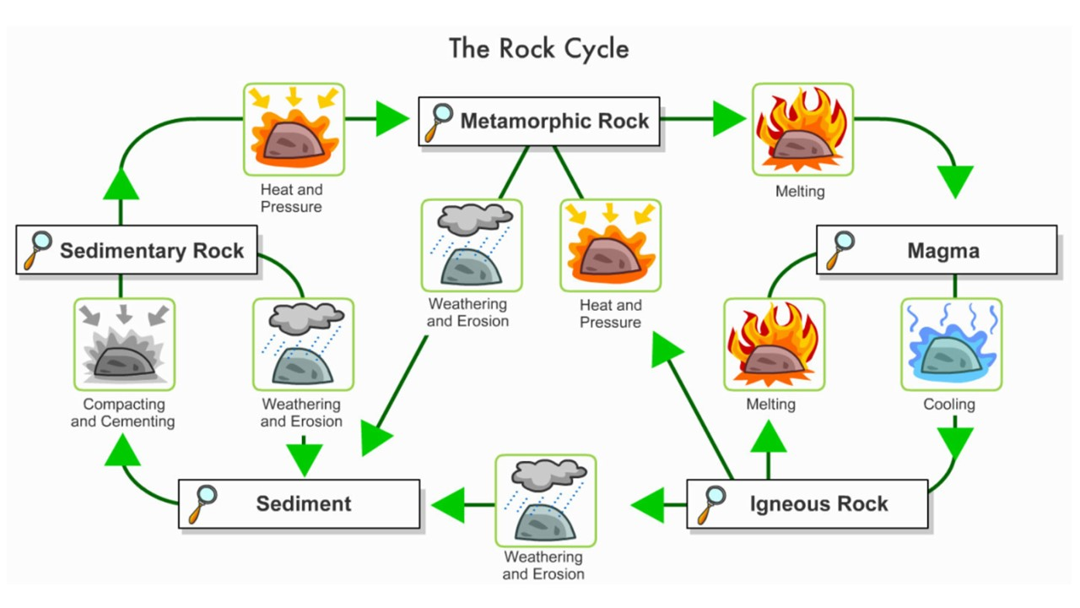

The following questions can be answered by referring back to your diagram above.

1. To go from Magma to Igneous we need to

|  |
| --- |
| cooling |

1. To go from Igneous back to magma we need to

|  |
| --- |
| melting |

1. Making Igneous become Sediment requires

|  |
| --- |
| Weathering and erosion |

1. To go from Sediment to Sedimentary Rock we need to

|  |
| --- |
| Compaction and cementation |

1. To change from Sedimentary rock to Sediment we

|  |
| --- |
| Weathering and erosion |

1. Changing from Sedimentary to Metamorphic requires

|  |
| --- |
| Heat and pressure |

1. Making Metamorphic become Sediment requires

|  |
| --- |
| Weathering and erosion |

1. Changing from Metamorphic to Magma uses

|  |
| --- |
| Melting |

1. Changing from Igneous to Metamorphic requires

|  |
| --- |
| Heat and pressure |